City Newsletter

January / February 2024



Table of Contents

Purpose… 3

*Welcome to the TEAM, Tasha!!!* 4

*Current Projects & Collective Achievements…* 6

Now Hiring… 7

Board of Review 9

*Missaukee Area Chamber* 10

*Risk Management* 11

*City Revenues* 13

*2024 Camping Season* 15

Did you check the website? 17

Fire Services & Important Contacts… 18

Closing 19

Purpose…

Hello, TEAM CLC…

In this newsletter, we are sharing some of the city’s recent achievements and we want to publicly thank the city’s staﬀ, and further all stakeholders that have supported the City of Lake City and the greater community. I believe we ALL should be justifiably proud of our progress. We also recognize there is still much work to be conducted, though recent efforts should be memorialized! As always, the ensuing document will not capture all your achievements during the delineated period, but we wanted to take a moment to outline progress and try to touch on some of the highlights. We will continue to look for opportunities to ensure we are meeting professional and legal standards including ongoing implementation of prudent fiscal practices, and further we would like to drive projects and pursue opportunities to improve the current footprint of the CLC. In addition, we will continue to assess principal documents such as the City Charter, Ordinances, Master Plan/Parks and Rec Master Plan, and further the collective vision of City Council. In short, we will:

* Continually work effectively as a team and provide exceptional customer service for the citizens and visitors alike, in this great community.
* Implement and continually revisit policies and procedures to ensure effective and efficient operations.
* Support the City Council to ensure we are appropriately sharing information, so they can make informed decisions.
* Ensure the Mayor, City Council, and the respective Boards and Committees are supported and further kept apprised, so they can make informed decisions.
* Giving thanks to our staff and community partners.
* We are actively searching for someone to help with the Office of the Treasurer as an appointed member, so contact us if you are interested.
* Last, we are hopeful the information outlined in this newsletter proves useful.

*Welcome to the TEAM, Tasha!!!*

We are excited to share that Tasha G. has joined the CLC team! She has a lot of work and life experiences that will be invaluable in her new role. In short, please come introduce yourself and offer her a warm CLC welcome when you see her! In terms of her working title(s), she will ultimately serve as our Utility Billing Manager and Deputy Treasurer. As a first step, she graciously started to work on some organizational tasks around the office (including mangement of miscellaneous papers, files, and old equipment), she’s reviewing documents/information for her own edification, and she’s already learning about State of Michigan prescribed record retention schedules and city ordinances, too. In addition, I am extremely impressed with her ability to identify discrepancies in our billing software, which is likely a testament to her years of book keeping expereince. I am hopeful we can retain her for many years, and I am appreciative that she’s already documenting some of the highly prescriptive processes in the office, so we can develop a body of knowledge to build/share/advance over time.

As an initial introduction, Tasha responded to a couple of questions, so you can start to get to know her, see below for the questions and her responses.

What’s your favorite Sports team?

She conveyed that her favorite sports team is whatever team her kids are playing on.

Dream car?

Lamborghini…. She said in blue… always blue…

What do you enjoy doing?

She enjoys gardening, DIY projects, and she devotes most of her time and efforts to her kids.

How long have you resided in the area?

Since 1992 she has resided in Michigan, her family moved to the Village of Marion when her father retired from the military, and they lived close to her grandparents. She is also a proud graduate of Marion H.S. ---- Go Eagles!!!

What are you looking forward to with this new position with the CLC?

She conveyed that she’s looking forward to interacting with citizens, learning new things, and being part of a team.

*Current Projects & Collective Achievements…*

First, I am excited to report that we have made considerable progress on our utility billing software and related hardware upgrades. It is difficult to quantify, but this has been a big project for our team, and our staff continues to make progress. We are looking forward to the prospect of getting back to a ‘normal’ billing period soon.

* As we move forward, we would like to discourage the practice (to the extent possible) of taking over/under payments for utility bills, and we recognize some have been doing this practice for a long time, though the perceived convenience factors will hopefully represent a dated idea once we offer auto bill pay or by sending bills via email, etc.
* In addition, the city’s Assessing, Utility, and Tax data will now safely exist in the metaphorical BS&A cloud.
  + In terms of our related program data, the vendor has taken on the responsibility for security and related data backup and general management.

Now Hiring…

The City of Lake City is currently seeking applicants for open positions, including an appointed Treasurer position and we have other opportunities to serve on the Board of Review and the Planning Commission. If interested, please email a copy of your resume to [vautawr@cityoflakecity.com](mailto:vautawr@cityoflakecity.com).

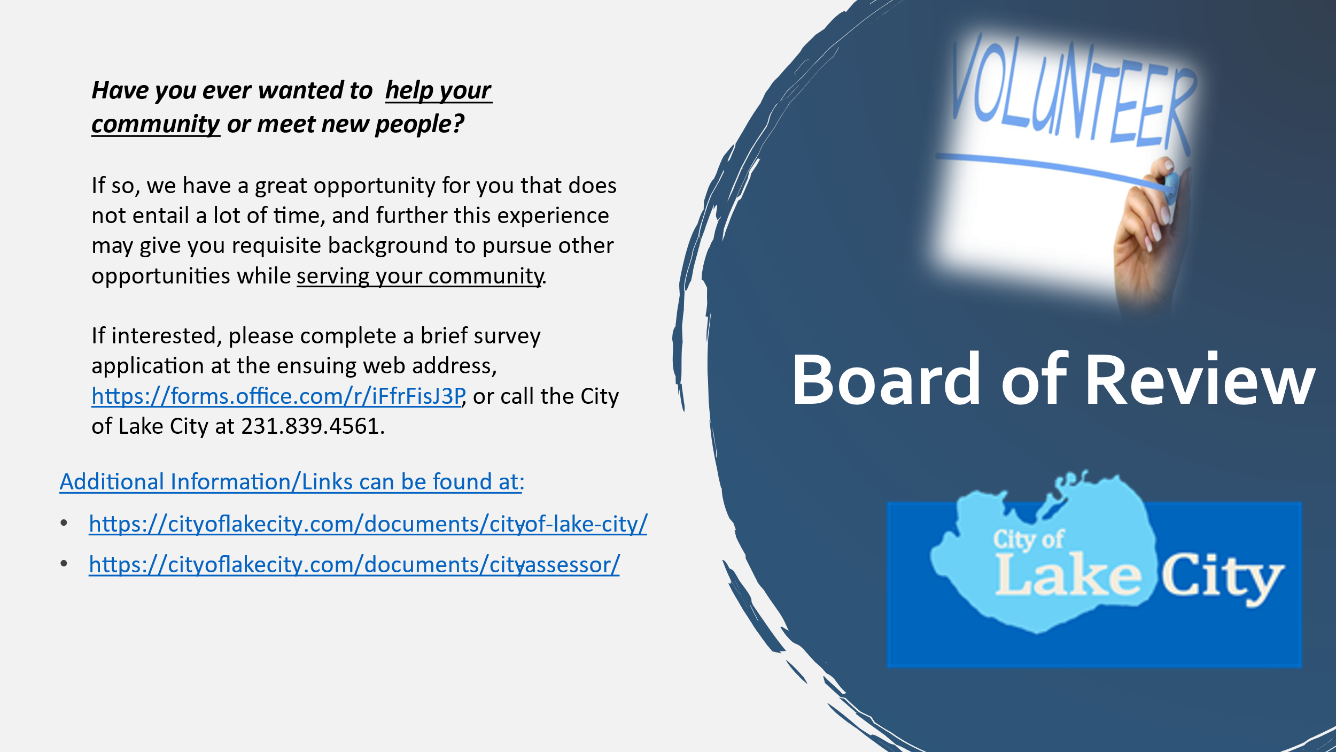

Board of Review

We are seeking volunteers to serve on the city’s Board of Review. Of note, these are critical position(s), and they also are an opportunity to gain city government experience without a huge time commitment. If interested, please send a message via the contact page of the city’s website.

In addition, the Board of Review has set the 2024 meeting dates, see the adjacent infographic.

*Missaukee Area Chamber*

*Risk Management*

We recognize the want/need to ensure that any activities that are an elevated risk and low frequency types of activities should be driven by a specific policy/procedure with a mechanism or a prescriptive process with specific guidance. In most instances, these types of activities need ongoing communication and direct oversight with the responsible manager. Please see the ensuing (blue) funnel and table, which I hope helps conceptualize this information as we assess various tasks/responsibilities. If the item resides at the narrow part of the funnel, or to denote the activity is high risk (cost or personal injury) and/or is a new challenge or new/unknown event (so low frequency) there should be some additional evaluation, especially if we don’t have a specific policy or procedure to follow and adhere to (see the ensuing table for a couple of examples).  As an alternative example, we offer new hires an opportunity to get a TB vaccination, and further certain activities call for specific training, such as bloodborne pathogens, which is an area our City Superintendent has recently revisited and will provide staff with training. There also are instances when our staff perform work in confined spaces, so we bought a trench box and there are prescriptive internal/external procedures to follow. As always, the breadth of challenges staff has faced in the police or fire service have other good examples, and the same could be said for many DPW operations.

*City Revenues*

According to MSU Extension, the ‘charges for services and ‘tax’ revenue represent the most significant revenue sources for local communities, and this observation is representative of the CLC revenues. Of note, most of the revenue is from ‘charges’ for services’ and ‘taxes’ (90% of taxes are from property tax revenues).

What is our mandate? As a Home Rule Chartered City, what are we supposed to do…?

As evidenced by the ensuing infographic, the foundation for local government (arguably or from their perspective) should be Infrastructure, Fiscal Resources, Governance, Community Engagement, and these areas reportedly buttress the ‘pillars’, or more specifically the ‘Quality of Life, ‘Economic Development’, ‘Public Health and Safety’, ‘Talent and Place’, and ‘housing’.  The collective categories may stand for a vibrant community. In terms of mandate and authority, we are much different from the state/federal government, and I believe our focus should always be on operations and/or good local governance. We can venture into other areas through discussion, though our impact or ability to drive change will be quite limited, and incongruent with delineated authority. It seems like the Master Plan(s), CIP, and other documents would or should be our definition or the cumulative total, see below infographic from MSU Extension.

*2024 Camping Season*

Did you check the website?

Please periodically check the website (<https://cityoflakecity.com/>) for more information and/or general city updates. If you have not been on the website, here are some recent examples of items you possibly missed, including:

* Link to contact us directly, [Contact – City of Lake City](https://cityoflakecity.com/contact/)
* Link to city news, [News – City of Lake City](https://cityoflakecity.com/news/)
* Link to document library, [Documents – City of Lake City](https://cityoflakecity.com/documents/)
* Link to the agendas, <https://cityoflakecity.com/document-category/meeting-agendas/>
* Link to our approved meeting minutes, <https://cityoflakecity.com/document-category/meeting-minutes/>
* Link to our finalized Resolutions, <https://cityoflakecity.com/document-category/resolutions/>
* Link to the City Board applications [Application and related Procedures for City Board and Committee Appointments – City of Lake City](https://cityoflakecity.com/documents/city-of-lake-city/), and General Application, <https://cityoflakecity.com/documents/employment-application-policy-and-application-document/>
* This is the ‘live’ link to our regular CC meetings, <https://cityoflakecity.com/join-city-council-meeting/>

Fire Services & Important Contacts…

As a reminder, the City of Lake City recently transitioned to the Lake Missaukee Fire Department for fire services *(*[*https://www.facebook.com/LMFD200/*](https://www.facebook.com/LMFD200/)*).*

Closing

This document was developed to outline some of the City of Lake City’s recent eﬀorts, general improvements, and further to serve as a mechanism to share speciﬁc staff and programmatic achievements. I am proud to report that our collective stakeholders including staﬀ, elected/appointed personnel, and part-time and/or seasonal staﬀ have made measurable progress in many program areas. We would not have been so successful without support from the collective team, so we are hopeful our staﬀ, personnel, and all area stakeholders are happy with the observed progress, especially since we have continually operated within the ﬁscally prudent conﬁnes of a lean structure and we will continue to look for opportunities to improve budget processes.

In closing, we will continually work with the collective City Council to drive city projects and eﬀectively support our team members in all operations. As always, the goal is to develop conﬁdence, professionalism, and abilities within our team, so we are ready to take on any project or challenge, as we strive to provide the highest level of service possible for our citizens and in support of the greater community. We will continue to keep you apprised of our progress, please check back on the website for updates and emergency alerts, or please see us at the next City Council meeting. As always, thank you for your ongoing interest and support!